***Geography: Exam Revision***

Define urbanisation: The gradual increase in percentage of people moving from rural areas into urban areas (city/town).

Definition of an urban place: a town or city that contains 2000+ people living there.

5 causes of urbanisation:

* Employment: urban areas provide vast amount of job opportunities for different types of people, from administrative to professional to casual.
* More specialised services: urban areas provide different types of services available to cater to all different needs of people. Examples: surgeons, dentists.
* More opportunities for women: there are more opportunities for women who live in urban areas as there are more types of options available.
* Higher paid jobs
* More resources for better standards of living.

Characteristics of urban areas:

* Density rich population.
* High cultural heterogeneity.
* Well-developed infrastructure
* Sense of anonymity
* High job opportunities

Effects of urbanisation in urban areas:

Increase in cost of living, urban sprawl, stressful, traffic congestion

Effects of urbanisation in rural areas:

Decrease in population, less employers for businesses, fly-in/fly-out work patterns

What is urban growth: increase in number of people living in urban areas

Define ‘rural place’: a countryside settlement geographically located outside of towns or cities with less than 2000 people.

Examples of rural places: Serpentine, Jarrahdale, Mandurah

Characteristics of a rural area:

* Less than 2000 people
* Large agricultural farming
* Low degree of traffic and noise
* Long-lasting relationships (as they deal with the same people).
* High quality environment

Challenges in rural places:

* Population loss: more people going to live in urban areas. Consequence: less workers in rural businesses, leads to decrease in jobs.
* Isolation/remoteness
* lack of transportation
* lack of resources
* declining political influence

Differences between urban and rural areas:

|  |  |
| --- | --- |
| Urban | Rural |
| Higher population: 2000+ | Lower population: -2000. |
| High pollution levels | Low pollution levels |
| High traffic | Low traffic |
| Higher job opportunities | Limited job opportunities |

How are urban and rural areas interdependent:

* Food: food produced in **rural** areas by farmers, imported to **urban** areas as produce.
* Waste management: **urban** areas transport waste to rubbish tips in **rural** areas.
* Infrastructure: **urban** areas wealthier, build houses for **rural** areas.
* Environment: both **urban** and **rural** areas responsible for protecting the environment, from national parks to conservation sites.

What is urban sprawl: the outwards expansion of an urban area.

Negative consequences/problems of urban sprawl:

Longer travel times

Increase in traffic

Higher pollution (link to traffic)

More funding needed to create transport networks

What is traffic congestion: a state in transport that involves the cramming of vehicles in the road.

Causes of traffic congestion: urban sprawl, overpopulation (increased by 0.6 million from 2011), bad networks, poor public transport

Scope: mainly in CBD (Kingsley, Wanneroo Road, next to Victoria Park.

Characteristics of traffic congestion: longer road trips, traffic jams, slower speed rates.

Define stakeholder: person, group, party or organisation that is directly or indirectly effected and influenced by an issue.

Traffic congestion stakeholders:

Business workers: less punctuality, less customer satisfaction, more time spent on road, schedules ruined, less job productivity

State government: pressure to fix traffic congestion, money spent on traffic congestions, responsible with using resources effectively

Planning strategies in Perth used to deal with traffic congestion:

Directions 2031: framework for future growth of Perth. More housing, infrastructure, affordable housing, protecting natural environment.

Transient-oriented development: increase of facilities within walking distance of public transport. **Example: Apartments built next to Mirrabooka Bus station.**

Infilling: more construction of facilities and zones in already existing urban land.

Graham Farmer and East Parade Upgrade: costed $14 million, extension of lanes and westbound onramp.

Urban Processes:

What is urban sprawl: gradual expansion of an existing urban area. Examples:

**Perth: expansion north to Lancelin and south to Myalup. Jakarta: expansion south to Kemang.**

What is invasion/succession: movement of a function into a region, causing previous land use functions to become replaced.

What is renewal: land redevelopment in an urban area that is government initiated.

What is planning:

What is land use competition:

What is inertia:

What is agglomeration: the clustering of similar functions, either horizontally or vertically.

Define internal morphology: the internal pattern of functions found within an urban city.

Define functional zone: a geographical entity with common functional and structural characteristics.

***Main functional zones within Perth:***

* **CBD:** node (focal point of functions), recreational (Supreme Court Garden), commercial/residential zonation, horizontal and vertical zonation.
* **Inner Mixed Zone:** zone of transition around CBD. Mix of land uses such as warehouses, transport depots and light industry.
* **Residential Zones:** Mirrabooka, Morley, Balga, etc.
* **Industrial** **zones**: Balcatta,
* **Outer** **business** **districts**: smaller commercial and retail functions (Midland, Armadale)
* **Special** **purpose** **zones**: Kings Park, Perth Airport, Herb Graham, Sir Charles Gardiner Hospital.
* **Rural-Urban** **Fringe**:

Five major sections of Jakarta and their main features:

Central Jakarta: smallest city, large parks and Dutch colonial buildings.

North Jakarta: bounded by Java Sea, Tanjong Priok, large/medium industries.

East Jakarta: several industrial sectors, international airport, 10 districts.

South Jakarta: affluent residential areas (Pondok Indah), upscale shopping centres, much of CBD in South Jakarta.

West Jakarta: small-scale industries, Dutch colonial landmarks, has Jakarta’s Chinatown.

A megacity is:a city in excess of 10 million people as its permanent population.  
  
consequences of urban sprawl: traffic congestion, loss of natural ecosystems, species extinction, increased carbon dioxide.

Factors determining Perth’s external morphology:

* Swan river – people building close to river as it is a major source of water.
* Water mounds – Gnangara water mound, which is a source for 60% of Perth. Mound is protected, so external morphology is kept away from it.
* Urban sprawl: which is the outwards expansion of an area. External morphology of Perth is pushed outwards, as urban sprawl results in more land for use.
* Indian Ocean: barrier to the west of Perth.
* Darling Scarp: prevents development to the east.

Factors determining Jakarta’s external morphology:

* Cilliwung River – people building close to it as it is a major source of water.
* Java Bay: barrier to the north of Jakarta
* Population increase: 2010 – 9.6 million, 2016: 10.3 million
* Hills south of Jakarta:

Site features of Perth:

* Indian Ocean
* Swan River, south of Perth
* Rottnest Island: west, offshore Perth.
* Quindalup dunes: scattered along coastline of Perth.
* Stirling range: (south-east) – range of mountains and hills

Site features of Jakarta:

* Java Bay
* Cilliwung River
* Flat low lying land
* Hills south of Jakarta

|  |  |
| --- | --- |
| Definition | Examples |
| Define biome: large parts of the earth’s surface with similar environmental conditions and organisms.  Define natural biome: a major community of plants and animals in the earth’s surface that is not modified by man and existing in its original physical state. | Chaparral – Cape Town South Africa, west coast of USA  Desert – Central Australia, Africa  Aquatic – Great Barrie Reef: Queensland  Grassland – North Australia,  Forest – Africa, Australia, Brazil, Peru  Tundra – Alaska, Canada, Siberia (North Poles) |
| Define anthropogenic biomes: a biome modified by man | Croplands, rangelands, |
| Define land use: the way that land functions | Farming  Housing  Urban areas  Commercial use  Special purpose zones |
| Define land cover: physical material at the surface of the earth. | Forestry (tropical rainforest in S.A)  Grassland (savannahs of Northern Australia)  Water  Soil  Wetlands (Camargue in France) |
| Define land cover change: modification of land by man | PERTH: infilling, extension of freeways (Kwinana), Elizabeth Quay, Invasion of market gardening areas (Osman Park), School closures, Perth Stadium – lakes swamps.  AGRICULTURE: Dairy industry (south west of WA), orcharding (Darling Rangers), wheat – sheet belt.  AMAZON RAINFOREST: cattle ranching, habitat fragmentation.  TEMPORATE FORESTS: (south west of WA) clear cutting of forests, acid rain (emissions)  Boreal forests: North America, Russia – forest fires, logging. |
| Define ecosystem structure: types of components that make up an ecosystem and how they’re related to one another. | Atmosphere, water, vegetation |
| Define ecosystem dynamics: the functioning of an ecosystem. | Plants, animals |
| Define biodiversity loss: reduction of species in an environment. | Jarrah Trees |
| Define deforestation: the permanent removal of vegetation from earth’s surface. | Amazon rainforest in South America  Cinchona trees in Africa  Congolese rainforest in Congo  Temperate rainforest – east of Australia |

**Deforestation:** the removal of natural vegetation from earth’s surface, such as that of from the Amazon Rainforest.

Define biomass: density of organisms in any given area.

**Causes/ reasons of deforestation:**

Urban sprawl (north and south of Perth)

Agriculture (beans, corn, crops)

Timber production: tables, chairs, cupboards

Overpopulation (Perth: 1.72 million in 2011, 2 million+ in 2019)

Industrialisation: Balcatta

Mining (Bauxite mining - Jarrah Forest WA)

Medicine (steroid drugs, Quinine for Malaria, alkaloid, plants with anti-cancer properties)

***Hydrological (water) Cycle:***

Definition: continual movement of water though earth’s surface.

Process:

**Evaporation:** water turning into water vapour (liquid to gas). Evaporation occurs from major sources of water such as the Indian Ocean.

**Transpiration:** essentially the ‘process of evaporation in plants’.

**Condensation:** formation of water particles into clouds.

**Precipitation:** release of water from clouds. Caused by low pressure system which releases rainfall.

**Water infiltration:** water penetrating through earth’s surface (soil).

**Groundwater runoff:** movement of water from high to low ground, reaching the oceans and seas.

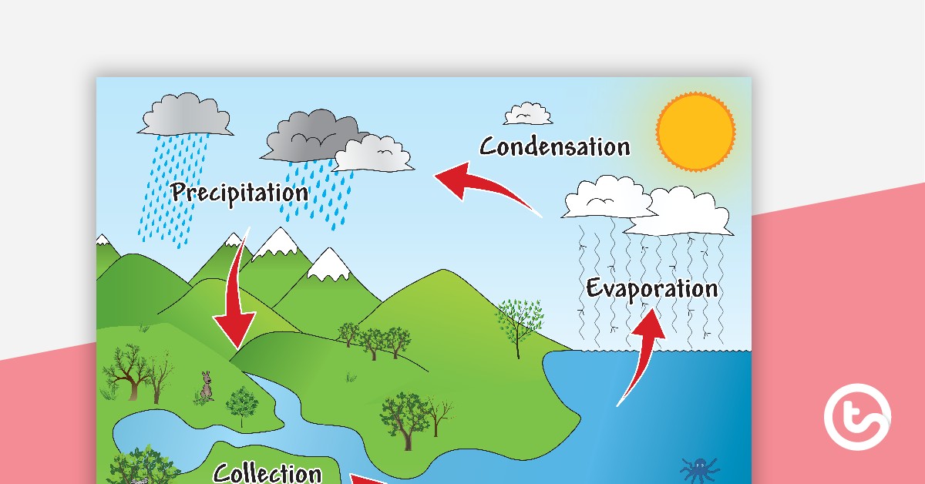

**Factors that can affect the water cycle (anthropogenic impacts):**

* Deforestation: less transpiration
* Chemical discharges: overabundance of nutrients such as phosphates (from fertilisers). Creates algal blooms that deplete oxygen levels. Decreases evaporation
* Sewage plant systems: bacteria and diseases due to poor sanitation (e.g. Africa). Bacteria develops 🡪 water systems cannot be used for evaporation.
* Urbanisation/ urban development: less autotrophs (vegetation) for photosynthesis as they’re being cleared for cultural development (houses, buildings). Leads to less transpiration levels.

What is remote sensing: technique used to gather information about an object in earth’s surface without having to physically touch it.

Usefulness of remote sensing: take pictures of land to examine changes overtime, spatial patterns

***Traffic Congestion: Jakarta: Strategies:***

*Toll road:*

* A road that can be accessed for passage by paying a fee.
* Designed to take some cars from adjacent highways and roads.
* Example of a toll road is the Jakarta Inner Ring Road

*Bus lanes:*

* Are specifically marked lanes that only buses can drive on.
* Found alongside the canals of West Jakarta. Bus lanes fall under the BRT (Bus Rapid Transit) system
* BRT system was established in 2004 and helps carry 350,000 people a day.

*BSD City:*

(Bumi Serpong Damai) in south-west of Jakarta.

Major development of a satellite community.

BSD city is located along the Serpong District of South Tangerang, within Greater Jakarta.

Great emphasis on the city acting as a reason for people and businesses to relocate.

*MRT (Mass Rapid Transit):*

Began operation in 2019. The MRT consists of 16 train carriages.

A single MRT train consists of 6 carriages, with every carriage being able to hold approximately 2000 passengers.

Means that there are less cars on the road at any given time.

**Climate change:**

Definition: a statistical difference in weather conditions (such as rainfall and humidity) in an area over an extended period of time. Causes can be natural (earth’s orbit) or anthropogenic (fossil fuel combustion). Causes can alter concentrations of greenhouse gases.

**Natural causes of climate change:**

* Volcanic eruptions:
* Solar output
* Forest fires (Amazon Rainforest)
* Melting Permafrost
* Ocean currents

**Anthropogenic causes of climate change:**

* Combustion of fossil fuels
* Urban development
* Industrial Revolution
* Mining
* Deforestation
* Landfill waste

**Great Green Wall (climate change strategy):**

* Flagship initiative in Sahel region of Africa.
* Involves the implementation of reafforestation to reverse desertification due to climate change.
* Countries involved: Burkina Faso, Senegal, Mauritius, Niger, Ethiopia, Sudan, etc.
* Planting trees 🡪 increased transpiration.
* Millions of hectares of land to be restored.
* Results in more carbon dioxide taken in by plants from earth’s atmosphere.
* Can increase rainfall, thus reducing effects of climate change (heat, low rainfall, drought, etc)
* Increased albedo - helping to reduce heat retained by earth.

**Heat Budget**

Define heat budget: Balance between incoming heat energy absorbed by the earth and outgoing heat energy in the form of radiation.

*Process of the heat budget:*

* Solar radiation (sun) powers climate system.
* Some solar radiation is reflected by earth’s atmosphere.
* 51% of radiation is absorbed by earth’s surface and warms it.
* Infrared radiation (longwave) is emitted from earth’s surface.
* Some infrared radiation passes through the atmosphere, but most is absorbed by gas molecules and clouds.
* Results: warms earth’s surface.

Define albedo: the level to which a surface can reflect sunlight. Lighter surfaces 🡪 higher albedo. Darker surface 🡪 lower albedo. Darker surfaces absorb (opposite of reflect) the heat.

Define absorption: way that heat is taken by water, land and atmosphere and being ultimately converted into long wave radiation.

Define conduction: the passing of heat from the earth to the atmosphere by direct contact.

Define convection: movement of air through differences in temperature.

Define greenhouse effect: the capacity to which greenhouse gases in earth’s atmosphere (carbon dioxide, methane, water vapour) trap the sun’s heat.

Define insolation: incoming solar radiation to the earth.

Define latent heat: stored heat.

Radiation: transference of heat.

**Anthropogenic impacts on the Heat Budget:**

* Fuel combustion: more gas released into atmosphere (such as from vehicle exhausts). Release more pollution
* Land albedo change (deforestation, urban sprawl).
* Rapid urbanisation: higher energy demands. Urban materials absorb and retain more solar radiation than do soil + vegetation.

**Carbon Cycle**

Definition: constant movement of carbon from atmosphere, earth and organisms.

* Carbon is a life-sustaining element found in living organisms and in the environment.

*Process of the carbon cycle:*

* Carbon moves from the atmosphere to plants (photosynthesis).
* Carbon moves from plants to animals (food).
* Carbon moves from plants and animals to soils (can decompose, die)
* Carbon moves from living things to the atmosphere (respiration).
* Carbon moves from fossil fuels to the atmosphere when fuels are burned.
* Carbon moves from the atmosphere to the oceans.
* Oceans also contain autotrophs for photosynthesis (phytoplankton).

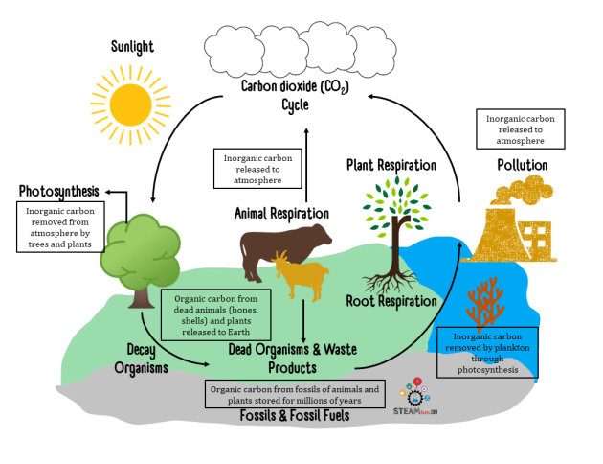

Anthropogenic impacts on the carbon cycle:

* Deforestation: less carbon taken from atmosphere due to less plants available for photosynthesis. Example: Amazon Rainforest.
* Reafforestation: more carbon taken from atmosphere due to more plants available for photosynthesis. Example: the Sahel and the Great Green Wall Project
* Industrialisation: industrial facilities release smoke from chimneys in exponential rate.
* Power stations: release high amounts of carbon to generate electricity. Example: Collie Station.
* Agriculture: soil is huge reservoir (storage pool) of carbon. When soil is interfered with, carbon is released.
* Burning fossil fuels: carbon produced from burning fossil fuels such as coal for energy.
* Vehicle exhausts: release carbon when being operated. Cars spend more time on road 🡪 more carbon released. Example: traffic congestion: Wanneroo Road.

**World Atmospheric Circulation:**

Define cell: area of moving air in earth’s surface. Moves up into the atmosphere and into the poles.

Hadley cell: convection current formed at the equator. Rises into atmosphere and subsides 30* north and south of equator. Air is rising.

Define Ferrell cell: movement of air in the mid latitudes 30*- 60* north and south of equator. Cell is considered ‘wild’. Air is subsiding.

Coriolis effect: way that air in southern hemisphere is deflected to the left (anti-clockwise).

High pressure: area in the atmosphere where the pressure is in excess of 100 h.p. Air is stable (warm, heavy + dense) as it drops. Low rainfall (lack of moisture).

Low pressure: areas of the atmosphere where air is less than 100 h.p. Air is rising and unstable. Forms clouds closer to equator. High rainfall.

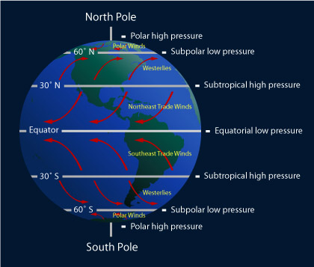

**World temperature patterns:**

January: south of equator is hotter. Examples: Australia, Africa, South America

Areas of cold temperature: Antarctica, Greenland, Russia.

July: Northern hemisphere tilted towards the sun.

Hotter in south of North America, north of South America and North of Africa.

Site of Perth:

**Define site: immediate physical features of an area or location.**

1. **The Swan Coastal Plain:**

* Up to 60 metres in height. Increases in height towards the east.
* Plain is mainly sand dunes of different geologic ages.
* Up to 30 kilometres wide.
* Undulating land
* North-south linear pattern of swamp and shallow lakes.
* Gnangara and Jandakot water mounds

1. **The Swan and Canning Rivers:**

* Start on the Darling Plateau and cross the coastal plain to reach the Indian Ocean.
* Reaching up to 15km inland from coast.
* Crossed by roads and bridges at narrow points.

1. **The Darling Scarp:**

* Western edge of Great Western Plateau.
* Rises from the coastal plain to a height of about 320 metres.
* Steep sided valleys are cut into the Scarp by rivers that flow on the coastal plain.
* Soils are mainly clay with areas of granite outcrops.

1. **Coastline:**

* Westernmost boundary of the metropolitan area.
* Continental shelf is generally shallow: less than 10 metres deep and up to 5kms offshore.

Internal Morphology of Perth:

**Define internal morphology: the internal pattern of functional zones found within the urban city of Perth. A functional zone is a group of similar land uses found in an urban area.**

1. **Central Business District (CBD):**

* Up to 1.5 km in size.
* Located on site of its original settlement.
* Bordered by Victoria Avenue, Milligan Street and Wellington Street.
* Perth’s smallest functional zone.
* Vertical and horizontal integration (e.g. office and retail precincts).
* Pedestrian oriented development - around 85,000 workers per day.
* Historic sites such as the Cathedral.
* Special purpose zones scattered throughout the city. Examples include Perth Airport, UWA, Sir Charles Gairdner hospital and Murdoch University.
* Contains highest land values.
* Residential and commercial zonation (e.g. Mirrabooka’s The Square)

1. **Inner Mix Zone:**

* Zone of transition surrounding the CBD.
* Urban blight: poor quality and substandard buildings.
* Horizontal zonation in West Perth (professional functions).
* Recent expansion into Subiaco, South Perth and Victoria Perth illustrates its dynamic growth.
* Specialist zones such as the entertainment zone in Northbridge.
* Mix of land uses such as warehouses, transport depots and light industry.

1. **Outer Business District:**

* Smaller commercial and retail functions (Midland, Armadale).
* Professional-commercial functions such as banking, accounting and medical services.
* Suburban shopping and decentralisation of commercial functions due to access of CBD becoming more difficult.
* Linear/horizontal development such as along Albany Highway and Scarborough Beach Road.

1. **Industrial Zones:**

* Light-heavy industrialised activities (e.g. warehousing, fabrication and food processing.
* Heavy industry: Kwinana area.
* Agglomeration encouraging the grouping of related, complementary activities in all industrial zones.
* Light industry is often in close proximity to residential areas (e.g. Malaga, Osborne Park).
* Heavy industry often separated from residential areas by bushland buffer zones due to their potential to pollute.

1. **Residential land use:**

* This is the most extensive land use within the city.
* `includes housing and community facilities such as schools and halls.
* Residential age in long established suburbs such as Freemantle, Victoria Park and Leederville.
* Established suburbs such as Cottesloe and Nedlands.
* Northern and southern suburbs such as Greenwood and Bentley.

1. **Rural Urban Fringe:**

* Zone of transition at the edge of the city of Perth.
* Contains the most recent residential areas as urban land uses invade the rural areas on the outskirts of the city (greenfield developments).
* Brownfield development: new residential on old industrial sites.
* Highly present rural land uses such as market gardening, grazing and factory farming.
* Semi-urban land uses (hobby farms) providing owners and opportunity to work in a rural environment
* Contains landfill sites and sand quarries.
* Development of separate satellite settlements such as Ellenbrook.
* RUF examples: Two Rocks, Middle Swan.

1. **Special Purpose Zones:**

* Scattered all over the city.
* Educational facilities such as universities (ECU, UWA).
* Health precincts such as Fiona Stanley Hospital.
* Transport nodes such as Perth Airport.
* Military facilities (Swanbourne).

External Morphology of Perth:

**Define External Morphology: changes in the boundary and outward appearance of Perth (as shown through the Rural Urban Fringe.**

**Describe Perth’s External Morphology:**

* Semi-stellate
* 6418 square kilometres.
* 99 kilometres from north to south.
* Most development found within 30 kilometres of the coast.

**Factors that have influenced/determined Perth’s external Morphology:**

* **Indian ocean:** barrier to the westward expansion of development.
* **Darling Scarp:** barrier to the eastward expansion of development due to its rising height levels of up to 300 metres.
* **Swan coastal Plain:** generally flat and easy to build on, has encouraged urban sprawl.
* **Groundwater mounds** (Gnangara and Jandakot): protected from urban development.
* **Urban sprawl:** outwards expansion of Perth due to more demand of land use.
* **North-south shape of coastline:** has influenced north-south development.
* **Historically:** Swan River settlements prior to 1890 (e.g. Freemantle, Midland and Armadale.)

**IMZ**

**Medium quality residential**

**Rural-urban fringe**

* Railways developed in early 20th century.

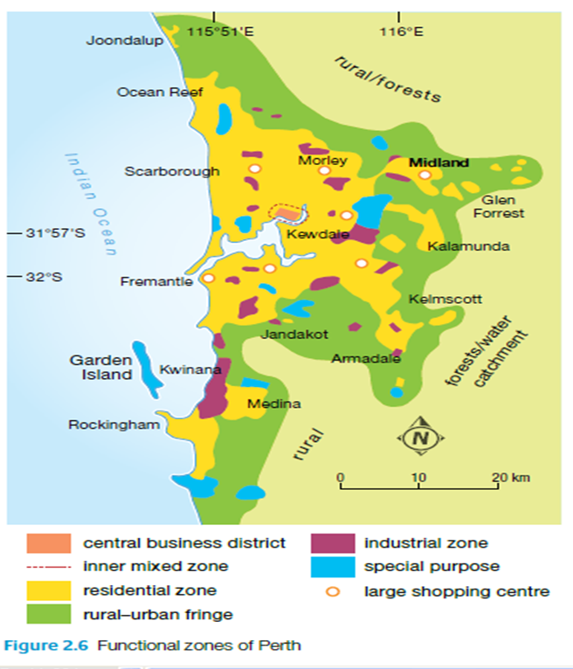

Concentric Zone Model of Perth’s Internal Morphology:

* Land use zones arranged in concentric circles.
* People able to afford highest rents being found at centre.
* Rents decrease further away from centre.

Perth – Challenges:

1. **Traffic Congestion:**

**Nature:**

* Slow flow of vehicles.
* It is a challenge for commuters that travel in and out of CBD and IMZ.
* Common during peak times (6am-9am, 3pm-6pm).
* Traffic congestion in Mitchell Freeway and major roads such as Marmion Avenue and West Coast Highway.
* Intersections such as Tonkin Highway suffers too.
* It is estimated that Perth could have 7 of the country’s 10 most congested roads by 2030.
* As up to 125,000 converge on central Perth today, worsening traffic congestion.

**Implications:**

* Loss of revenue and productivity.
* Estimated that cost of congestion will be $16 billion/year in lost productivity by 2030.
* Businesses suffer due to higher operating costs (more money on fuel).
* Residents on Perth’s fringe struggle to have access to roads due to traffic congestion.
* In Australia, Perth’s drivers experience the longest commutes.
* Some fringe residents spend more than 600 hours a year travelling to and from the CBD.
* Increased stress, air pollution (asthma).

1. **Urban Sprawl:**

**Nature:**

* rapid outward growth of low-density urban development. (e.g detached dwellings).
* e.g. Alkimos and Ellenbrook. They are referred to as ‘Greenfield Developments’, as they involve the removal of vegetation for housing.
* Currently metropolitan area extends 120 km north to south.
* Covers over 1600 square kilometres.
* Perth’s density is 1/10th of London’s.

**Implications:**

* Greenfield developments can cost $150,000.
* 920 hectares of land per year lost due to greenfield development.
* 70% of native vegetation on Swan Coastal Plain has been cleared.
* Biodiversity levels decline (e.g. Black Carnaby Cockatoo experiencing a 15& decline in population per year.

Perth – Planning strategies:

1. **Urban consolidation and Infill:**

* Aims to increase residential density in already established residential zones.
* Aims to slow down the rate of urban sprawl.
* Urban consolidation involves subdividing large blocks and buildings (Innaloo and Scarborough).
* Infill involves developing on under-utilised land (e.g. brownfield site).
* Target of 47% of new residencies to be built within current Perth boundary by 2031.
* Example of infill: project: Cockburn Coast Redevelopment.
* This project has implemented 6,000 new homes.

1. **Transit-Oriented Development (TOD):**

* Aims to increase amount of facilities/buildings within walking distance of public transport.
* Facilities can include leisure and commercial or housing.
* e.g. apartments built next to Mirrabooka Bus Station.
* E.g. Cannington TOD: five-minute walk to its train station, Sevenoaks Senior College, Cannington Leisureplex and Shopping centre.
* Perth government investing $5.4 billion in infrastructure in the 2018/19 federal budget.
* Other TODs include Mandurah Junction and Alkimos TOD.

Interrelationships between land cover change and climate change:

**Deforestation:**

* example of land cover change.
* Definition: permanent removal of vegetation for sections of earth’s surface.
* Deforestation common in south-east asia (Indonesia) and the Amazon.
* Purpose is to provide more space for land use
* Vegetation absorbs more heat than soil (higher absorption)
* If forests are removed, higher albedo of the surfaces.
* This means less heat is absorbed and less moisture taken up by the atmosphere.
* Leads to decrease in rainfall (less trees for transpiration).
* Carbon sequestration: process of storing carbon.
* Carbon dioxide released into atmosphere due to deforestation (biomass burning).
* Carbon dioxide absorbs heat energy.
* More carbon dioxide in atmosphere 🡪 more heat absorbed.
* Increases temperature.
* Global temperatures have increased by about 1* C since 1880.
* Rising temperature lead to melting ice sheets and glaciers.

**Urban development**

* Urban structures have darker surfaces.
* Increasing absorption of heat (lower albedo).
* Examples include buildings, roads and paved surfaces.
* e.g. annual temperature of a city with 1 million people or more can be as high as 3*C warmer than its outer edges.

(another example: urban sprawl= loss of habitat, ecosystems impacted)

Demographic Characteristics in Perth:

**Socioeconomic status:**

* Includes person’s education, type of occupation and income level.
* High socioeconomic areas 🡪 closer proximity to the CBD.
* Characterised by higher levels of income and educational qualifications.
* e.g. Cottesloe: in 2016, average median household about $3000 per week, compared to Perth median of $1,643.
* Lower socioeconomic status are areas further away from CBD, closer to industrial areas.
* e.g. in 2016, Koondoola had an unemployment rate of 15.5% compared to Peppermint Grove at 3.5%.

**Age concentrations:**

* Median age for Perth is currently 36.
* Older inner suburbs generally have higher median age.
* e.g. Claremont’s median age is 43.
* Newer suburbs such as Ellenbrook (25km from CBD) and Butler have higher proportion of younger families.
* E.g. Butler’s median age is 29 and almost 20% are aged up to 9 years.

Evidence of Climate Change:

1. **Global temperature rise:**

Increased over the years.

More greenhouse gases trapped, earth getting hotter.

Increased temperature of earth by 1*C since 1880.

18 of 19 warmest recorded years have all occurred since 2001.

1. **Shrinking ice sheets:**

Polar regions losing ice.

Between 1992 and 2011: Greenland has lost 15,2 billion tonnes of ice a year. West Antarctica lost 20 billion tons a year.

Increased temperature🡪 ice sheets melting.

1. **Sea level rise:**

Water from melting ice sheets.

Water expands as it warms.

Sea level is 5-8 inches higher than in 1900.

3.3mm increase of sea level rise per year.

Implications/effects/consequences of climate change:

1. **Health:**

* Elderly, young and sick most effected by increase in temperature.
* Heat exhaustion and dehydration levels increase.
* Diseases such as Ross River Virus become more prevalent.
* Increased spread of Malaria (occurs in hotter conditions).
* Increased pollution affects health (asthmatics).

1. **Extreme weather events:**

* 5-10% more intense.
* 20-30% more rainfall.
* Increase in winds and flooding due to sea levels rising.

1. **Bushfires:**

* Bushfires become more intense.
* Hotter and drier conditions increase the length of fire seasons.
* Bushfires: 20% increase in methane.

1. **Ecosystems:**

* Coastal wetlands: sea level rise.
* Inland ecosystems become drier and expand in area.
* South west of WA: 53% habitat loss for eucalypts.
* Alpines shifting to higher elevations.

Mitigation strategies for climate change:

1. **Reafforestation:**

* Increase carbon dioxide taken from atmosphere due to more plants.
* e.g. the Sahel’s Great Green Wall Project

1. **Electrically powered vehicles:**

* Do not emit carbon dioxide as they’re powered electrically.
* e.g. December 2018: France has half a million electric vehicles.

1. **Solar panels:**

* Reduces requirement of fossil fuels.
* Placed on roofs, generating electricity from radiation.
* e.g. Australia: 20% of households have solar panels.

1. **Transit-oriented Development:**

* e.g. Cannington TOD.
* Residential and commercial zonation built within walking distance of public transport.
* Less reliance on personal vehicular transport.
* Fewer fossil fuels emitted from vehicles.

1. **Public Transport:**

* More people relying on public transport.
* Less pollution released as less people are using personal vehicles.
* e.g. Perth’s Metronet.

|  |  |
| --- | --- |
| Liveability | Sustainability |
| * less stress. * Increased job productivity * Reduced air pollution in atmosphere. * Less money wasted. * More time with family * Reduced noise | * Cars: less ‘wear and tear’ * Less fuel consumption * Saving resources that are used for fixing cars (oil, water, metallic car pieces). * Water saved: 120,000 gallons of water required to produce a single car. |

**Jakarta:**

**Traffic Congestion:**

* In 2017, ranked as the world’s 7th most traffic congested city.
* Average travel time of 50 minutes.
* In 2020, number of motorcycles expected to be 66 million units.
* In 2016, 6180 cases of traffic accidents.
* Busy roads such as Sudirman street.
* 3.5 million people commute to work in the city every day.

**Planning strategy:**

**BSD CITY – Serpong District of South Tangerang**

* Independent city
* 6000 hectares (half the size of Paris)
* Environmentally sustainable (solar panels, double glass)
* Self-sufficient
* Educational facilities: 63 schools, colleges and universities combined.
* Residential areas near markets and schools.
* Aggregation (e.g. The Breeze: cinema, restaurants and Aeon Mall)
* Two major toll roads (e.g. Jakarta – Serpong Toll Road)
* Airport, Hotel Santika (special purpose zones)
* 40 minutes from CBD
* BSD Grand Boulevard

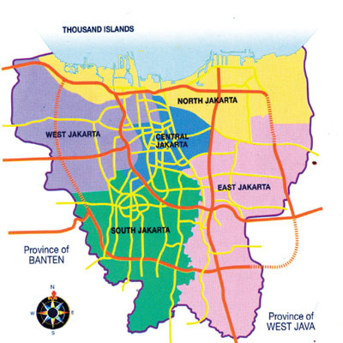

**Urban Processes:**

(Inertia: process that limits change)

**Inertia:** land use function remaining in its original state after the initial site advantages have declined. This can include schools.

**Processes that group functions: agglomeration and aggregation.**

**Agglomeration:** industrial functions being grouped together to make use of common infrastructure or to supply related products in a product chain.

**Aggregation:** grouping of like functions in a common location increases their public profile. Examples include aggregation in Nedlands of Sir Charles Gairdner Hospital, dental school, cafes and a recreational park.

**Processes that produce changes in urban land uses: centripetal and centrifugal forces.**

**Centripetal forces:** attraction of the city of Perth drawing in different urban functions. Influenced by pull factors such as well-developed infrastructure and serves, accessibility to transport, more work opportunities and agglomeration economies.

Push factors include lack of services, isolation and lack of customers and employment opportunities.

**Centrifugal forces**: attraction towards Rural Urban Fringe drawing in functions. Pull factors include cheaper land, low taxes, rural environment and increased privacy.

Push factors include traffic congestion, pollution and limited expansion opportunities.

**Invasion and succession:** established land use replaced by newer ones due to invasion. Once the land use functions have become the majority, then succession will have occurred.

**Urban renewal**: land redevelopment initiated by government.

**Urban redevelopment:** replacement and mending of buildings that is usually initiated by a business.

Internal Morphology – Perth: Practise Paper

|  |  |  |
| --- | --- | --- |
| **Functional Zone:** | **Features:** | **Examples in Perth:** |
| **CBD** | * Centripetal * Urban renewal/redevelopment | CBD. |
| **Special Purpose Zone** | * Aggregation * Inertia | DSC, Sir Charles Gairdner Hospital, Perth Airport, |
| **Outer Business District** | * Invasion/succession * Aggregation * Urban redevelopment |  |
| **Industrial Zones** | * Centripetal * Agglomeration * Invasion/succession | Balcatta, Kwinana, |
| **Rural Urban Fringe** | * Invasion/succession * Inertia   Urban redevelopment |  |
| **Inner Mix Zone** | * Invasion/succession * Inertia * Urban renewal |  |
| **Residential Zone** | * Urban redevelopment * Urban renewal * Invasion/succession * Centripetal * Inertia | Morley, Hillarys, Nollamara, Alexander Heights, Mirrabooka, Yokine. |